MEMORANDUM OF UNDERSTANDING
ON THE IMPLEMENTATION OF THE NORWEGIAN FINANCIAL MECHANISM
2014-2021
between
THE KINGDOM OF NORWAY,
hereinafter referred to as "Norway"
and
THE REPUBLIC OF BULGARIA,
hereinafter referred to as the "Beneficiary State"
together hereinafter referred to as the "Parties",
WHEREAS the Agreement between the Kingdom of Norway and the European Union on the Norwegian Financial Mechanism 2014-2021 establishes a financial mechanism (hereinafter referred to as the "Norwegian Financial Mechanism 2014-2021") through which Norway will contribute to the reduction of economic and social disparities in the European Economic Area;
WHEREAS the Norwegian Financial Mechanism 2014-2021 aims to strengthen relations between Norway and the Beneficiary State to the mutual benefit of their peoples;
WHEREAS the enhanced co-operation between Norway and the Beneficiary State will contribute to securing a stable, peaceful and prosperous Europe, based on good governance, democratic institutions, the rule of law, respect for human rights and sustainable development;
WHEREAS the Parties agree to establish a framework for cooperation in order to ensure the effective implementation of the Norwegian Financial Mechanism 2014-2021;
HAVE AGREED on the following:

Article 1
Objectives
- The overall objectives of the Norwegian Financial Mechanism 2014-2021 are to contribute to the reduction of economic and social disparities in the European Economic Area and to the strengthening of bilateral relations between Norway and the Beneficiary States through financial contributions in the priority sectors listed in paragraph 2. Accordingly, the Parties to this Memorandum of Understanding shall endeavour to select for funding programmes that contribute to the achievement of these objectives.
- The financial contributions shall be available in the following priority sectors:
- Innovation, research, education and competitiveness;
- Social inclusion, youth employment and poverty reduction;
- Environment, energy, climate change and low carbon economy;
- Culture, civil society, good governance, fundamental rights and freedoms; and
- Justice and home affairs.

Article 2

Legal Framework
This Memorandum of Understanding shall be read in conjunction with the following documents
which, together with this Memorandum of Understanding, constitute the legal framework of the
Norwegian Financial Mechanism 2014-2021:
- the Agreement between the Kingdom of Norway and the European Union on the Norwegian Financial Mechanism 2014-2021 (hereinafter referred to as "the Agreement");
- the Regulation on the implementation of the Norwegian Financial Mechanism 2014-2021 (hereinafter referred to as the "Regulation") issued by Norway in accordance with Article 10.5 of the Agreement;
- the programme agreements that will be concluded for each programme; and
- any guidelines adopted by the Norwegian Ministry of Foreign Affairs (hereinafter referred to as "NMFA") in accordance with the Regulation.
?

Article 3

Financial Framework
- In accordance with Article 2.1 of the Agreement, the total amount of the financial contribution is € 1,253.7 million in annual tranches of € 179.1 million over the period running from 1 May 2014 to 30 April 2021, inclusive.
- In accordance with Article 6 of the Agreement, a total of € 95,100,000 shall be made available to the Beneficiary State over the period referred to in Paragraph 1.
- In accordance with Article 3.2.b) of the Agreement, 1% of the total amount referred to in paragraph 2 shall be set aside for a fund for the Promotion of Decent Work and Tripartite Dialogue.
- In accordance with Article 10.4 of the Agreement and Article 1.9 of the Regulation, the management costs of Norway shall be covered by the overall amount referred to above. Further provisions to this effect are set out in the Regulation. The net amount of the allocation to be made available to the Beneficiary State is € 87,967,500.

Article 4

Roles and responsibilities
- Norway shall make funds available in support of eligible programmes proposed by the Beneficiary State and agreed on by the NMFA within the priority sectors listed in Article 3.1 of the Agreement and the programme areas listed in the Annex to the Agreement. Norway and the Beneficiary State shall cooperate on the preparation of concept notes defining the scope and planned results for each programme.
- The Beneficiary State shall assure the full co-financing of programmes that benefit from support from the Norwegian Financial Mechanism 2014-2021 in accordance with Annex B and the programme agreements.
- The NMFA shall manage the Norwegian Financial Mechanism 2014-2021 and take decisions on the granting of financial assistance in accordance with the Regulation.
- The NMFA shall be assisted by the Financial Mechanism Office (hereinafter referred to as the "FMO"). The FMO shall be responsible for the day-to-day operations of the Norwegian Financial Mechanism 2014-2021 and shall serve as a contact point.

Article 5

Designation of authorities
The Beneficiary State has authorised a National Focal Point to act on its behalf. The National Focal Point shall have the overall responsibility for reaching the objectives of the Norwegian Financial Mechanism 2014-2021 as well as for the implementation of the Norwegian Financial Mechanism 2014-2021 in the Beneficiary State in accordance with the Regulation. In accordance with Article 5.2 of the Regulation, the National Focal Point, the Certifying Authority, the Audit Authority, and the Irregularities Authority are designated in Annex A.

Article 6

Multi-annual Programming Framework
- In accordance with Article 2.5 of the Regulation, the Parties have agreed on an implementation framework consisting of the following financial and substantive parameters:
- a list of agreed programmes and the financial contribution from the Norwegian Financial Mechanism 2014-2021 by programme;
- identification of programmes, their objective, their main focus, as appropriate, the grant rate by programme, the bilateral ambitions as well as any specific concerns relating to target groups, geographical areas or other issues;
- identification of programme operators, as appropriate;
- identification of Donor Programme Partners, as appropriate;
- identification of International Partner Organisations, as appropriate;
- identification of pre-defined projects to be included in relevant programmes.
- The implementation framework is outlined in Annex B.

Article 7

Fund for bilateral relations
In accordance with Article 4.6 of the Regulation the Beneficiary State shall set aside funds to strengthen bilateral relations between Norway and the Beneficiary State. The National Focal Point shall manage the use of the fund for bilateral relations and shall establish a Joint Committee for Bilateral Funds in accordance with Article 4.2 of the Regulation.

Article 8

Annual meetings
In accordance with Article 2.7 of the Regulation an annual meeting shall be held between the NMFA and the National Focal Point. The annual meeting shall allow the NMFA and the National Focal Point to examine progress achieved over the previous reporting period and agree on any necessary measures to be taken. The annual meeting shall provide a forum for discussion of issues of bilateral interest.

Article 9

Modification of the annexes
Annex A and B may be amended through an exchange of letters between the NMFA and the National Focal Point.

Article 10

Control and Access to Information
The NMFA, the Office of the Auditor General of Norway and their representatives have the right to carry out any technical or financial mission or review they consider necessary to follow the planning, implementation and monitoring of programmes and projects as well as the use of funds. The Beneficiary State shall provide all necessary assistance, information and documentation.

Article 11

Governing Principles
- The implementation of this Memorandum of Understanding shall in all aspects be governed by the Regulation and subsequent amendments thereof.
- The objectives of the Norwegian Financial Mechanism 2014-2021 shall be pursued in the framework of close co-operation between Norway and the Beneficiary State. The Parties agree to apply the highest degree of transparency, accountability and cost efficiency as well as the principles of good governance, partnership and multi-level governance, sustainable development, gender equality and equal opportunities in all implementation phases of the Norwegian Financial Mechanism 2014-2021.
- The Beneficiary State shall take proactive steps in order to ensure adherence to these principles at all levels involved in the implementation of the Norwegian Financial Mechanism 2014-2021.
- No later than 31 December 2020, the Parties to this Memorandum of Understanding shall review progress in the implementation of this Memorandum of Understanding and thereafter agree on reallocations within and between the programmes, where appropriate. The conclusion of this review shall be taken into account by the National Focal Point when submitting the proposal on the allocation of the reserve referred to in Article 1.11 of the Regulation.
Article 12
Entry into Force
This Memorandum of Understanding shall enter into force on the day after the date of its last signature.
This Memorandum of Understanding is signed in two originals in the English Language.
ANNEX A

National management and control structures

1. National Focal Point
The Central Coordination Unit Directorate shall act as the National Focal Point.
The Central Coordination Unit Directorate is an administrative unit within the administration of the Council of Ministers. The Director of the Central Coordination Unit Directorate shall perform the functions of Head of the National Focal Point. The Central Co-ordination Unit reports directly to the Deputy Prime Minister for EU Funds and Economic Policy.
The roles and responsibilities of the National Focal Point are stipulated in the Regulation, in particular Article 5.3 thereof.

2. Certifying Authority
The National Fund Directorate (NF) shall act as the Certifying Authority.
The National Fund Directorate is an administrative unit within the Ministry of Finance. The NF is placed under the responsibility of a Deputy Minister of Finance responsible for the financial management of the EU Funds. The Director of the NF shall be the Head of the Certifying Authority.
The roles and responsibilities of the Certifying Authority are stipulated in the Regulation, in particular Article 5.4 thereof.
- Audit Authority
The Audit of European Union Funds Executive Agency (AEUFEA) to the Minister of Finance of Republic of Bulgaria shall act as the Audit Authority.
AEUFEA is functionally independent from the other bodies involved in the management and control system of the Norwegian Financial Mechanism 2014-2021 (e.g. National Focal Point, Certifying Authority, Programme Operators) in the Beneficiary State. It performs the audit activities according to internationally accepted auditing standards and requirements of the Regulation on the Implementation of the Norwegian Financial Mechanism 2014-2021. The Executive Director of AEUFEA shall be the Head of the Audit Authority.
The roles and responsibilities of the Audit Authority are stipulated in the Regulation, in particular Article 5.5 thereof.
- Irregularities Authority
The Central Coordination Unit Directorate (the National Focal Point) shall be responsible for the preparation and submission of irregularities reports. The Central Coordination Unit Directorate is an administrative unit within the administration of the Council of Ministers.
The roles and responsibilities of the Irregularities Authority are stipulated in the Regulation, in particular Article 12.3 thereof.
- Strategic Report
In accordance with Article 2.6 of the Regulation, the National Focal Point shall annually submit to the NMFA a Strategic Report on the implementation of the Norwegian Financial Mechanism 2014-2021 in the Beneficiary State. The Strategic Report shall be submitted to the NMFA at least two months before the annual meeting unless otherwise agreed.

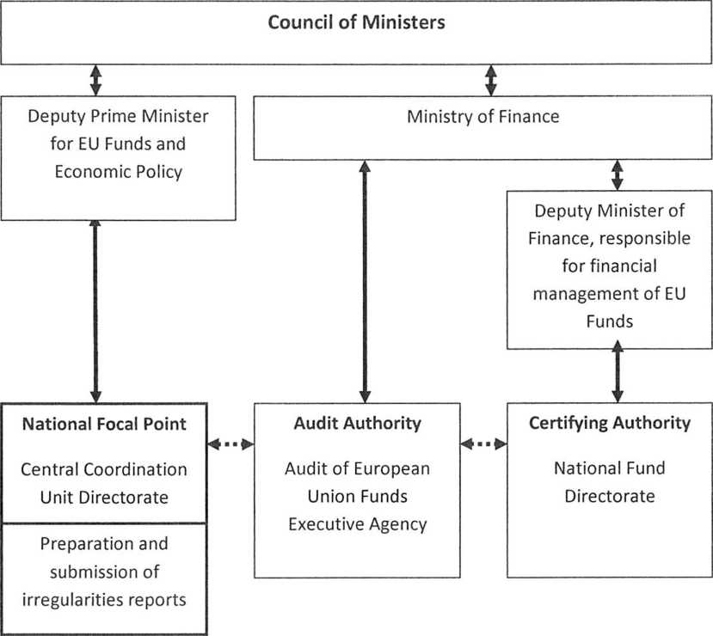

6. Organigram

ANNEX B

Implementation framework
In accordance with Article 2.5 of the Regulation, the Parties to this Memorandum of Understanding have agreed on an implementation framework outlined in this Annex.
1. Financial parameters of the implementation framework
'  ' | BULGARIA  ¹ ' • • • • • • Programmes | Norwegian FM contribution | National  contribution
1 | Business Development, Innovation and SMEs | € 28,500,000 | N/A
2 | Social Dialogue - Decent Work | € 951,000 | N/A
3 | Justice | €30,000,000 | € 5,294,118
4 | Home Affairs | €21,500,000 | € 3,794,118
 | Other allocations
 | Technical assistance to the Beneficiary State (Art. 1.10) | € 1,430,000 | N/A
 | Reserve (Art. 1.11) | € 3,170,500 | N/A
 | Reserve for completion of projects under FM 2009-2014 (Art. 1.12) | € 514,000 | N/A
 | Fund for bilateral relations (Art. 4.6.1) | € 1,902,000 | N/A
 | Net allocation to Bulgaria | €87,967,500 | € 9,088,236

- Specific concerns
Bilateral relations between the Kingdom of Norway and Bulgaria shall be strengthened with the aim of stimulating and developing long-term cooperation within all areas listed in the Annex to the Agreement between the Kingdom of Norway and the European Union. It is also an ambition to strengthen bilateral cooperation at political level and European level in areas of common interest.
The Parties to this Memorandum of Understanding agree that at least 10% of the combined total eligible expenditure of the programmes 'Justice' and 'Home Affairs' shall target the improvement of the situation for the Roma population. The Parties shall agree on how to reach this target through a plan to be coordinated by the National Focal Point.
- Substantive parameters of the implementation framework
The programmes described below are to be implemented subject to the approval of the NMFA, in accordance with Article 6.3 of the Regulation.
A. Programme: Business Development, Innovation and SMEs
Programme objective: Increased value creation and sustainable growth
Programme grant: € 28,500,000
 | Norwegian Financial Mechanism 2014-2021 BULGARIA
Programme co-financing: | Not applicable
Programme Operator: | FMO in accordance with Article 6.13 of the Regulation. Innovation Norway is appointed Fund Operator in accordance with paragraph 4 of Article 6.13 of the Regulation.
Programme area(s): Special concerns: | Business Development, Innovation and SMEs  Special concern shall be given to user driven research and development.
Bilateral ambitions: | €100,000 shall be allocated to the programme from the fund for bilateral relations. This does not prevent the Joint Committee for Bilateral Funds from allocating additional funds to the programme.

B. Programme: Social Dialogue - Decent Work
Programme objective: Strengthened tripartite cooperation between employer
Programme grant: Programme co-financing: | organisations, trade unions and public authorities and the promotion of decent work  € 951,000 Not applicable
Programme Operator: | FMO in accordance with Article 6.13 of the Regulation. Innovation Norway is appointed Fund Operator in accordance with paragraph 4 of Article 6.13 of the Regulation.
Programme area(s): | Social Dialogue - Decent Work
C. Programme: Justice
Programme objective: | Strengthened rule of law
Programme grant: Programme co-financing: | € 30,000,000 €5,294,118
Programme Operator:  Donor Programme Partner(s): | Ministry of Justice  Norwegian Ministry of Justice (NMOJ) - (to be decided)

Directorate of Norwegian Correctional Service (KDI) International Partner Organisation(s): Council of Europe (CoE)
Programme area(s): Effectiveness and Efficiency of the Judicial System
Special concerns: | Strengthening the Rule of Law Correctional Services and Pre-Trial Detention  A maximum level of funding available from the total eligible expenditure of the programme for infrastructure (hard measures) shall be identified in the concept note.  The programme shall include measures to increase the use of alternative sanctions to imprisonment.

Bilateral ambitions: | This programme shall contribute to the improvement of the situation for the Roma population and shall contribute towards the target set in section 2 'Specific concerns' of this Annex.  Special concern shall be given to the implementation of Human Rights standards - to strive towards a European judicial culture as well as to the child friendly justice.  Special concern shall be given to domestic and gender-based violence (improving legislation and training).  In developing the concept note and during the implementation of the programme, the Programme Operator shall seek to ensure synergies with the programme 'Home Affairs' in order to strengthen the justice chain, inter alia, regarding access to justice, good governance, gender-based violence and trafficking in human beings.  Synergies between the programme areas within this programme shall be ensured to strengthen the justice chain, inter alia regarding the use of alternative sanctions to imprisonment.  Interaction and cooperation with relevant civil society organisations shall be encouraged.  The Norwegian Courts Administration (DA) shall be actively involved in the preparation and may also be involved in the implementation of the programme, especially related to bilateral activities.  €100,000 shall be allocated to the programme from the fund for bilateral relations. This does not prevent the Joint Committee for Bilateral Funds from allocating additional funds to the programme.

D. Programme: Home Affairs  Programme objective: | Strengthened rule of law
Programme grant: Programme co-financing: | € 21,500,000 € 3,794,118
Programme Operator:  Donor Programme Partner(s): | Ministry of Interior  Norwegian Ministry of Justice (NMOJ) - (to be decided) Norwegian Directorate of Immigration (UDI) - (to be decided) National Police Directorate (POD) - (to be decided)

International Partner Organisation(s): Council of Europe (CoE) - (to be decided)
Programme area(s): International Police Cooperation and Combating Crime
Asylum and Migration
Good Governance, Accountable Institutions, Transparency
Special concerns: A maximum level of funding available from the total eligible
expenditure of the programme for infrastructure (hard measures) shall be identified in the concept note.
Special concern shall be given to asylum and migration with special focus on unaccompanied minors.
Special concern shall be given to police cooperation.
The possibility of pre-defining project(s) with the National Police Directorate (POD) and the Norwegian Police Service shall be explored when developing the concept note.
Special concern shall be given to domestic and gender-based violence (police training).
Special concern shall be given to the prevention and combating of corruption within the police.
This programme shall contribute to the improvement of the situation for the Roma population and shall contribute towards the target set in section 2 'Specific concerns' of this Annex.
In developing the concept note and during the implementation of the programme, the Programme Operator shall seek to ensure synergies with the programme 'Justice' in order to strengthen the justice chain, inter alia, regarding access to justice, good governance, gender based-violence and trafficking in human beings.
Bilateral ambitions: €100,000 shall be allocated to the programme from the fund
for bilateral relations. This does not prevent the Joint Committee for Bilateral Funds from allocating additional funds to the programme.

E. Projects under the Norwegian Financial Mechanism 2009-2014 funded through the reserve referred to in Article 1.12 of the Regulation
Name and number of project | Amount from reserve
BG10-0005 - Innovative production plant for bio fertilizer | € 514,000
Total amount | € 514,000

